How to request to join a user group once you have registered on the platform.
- Click “User control panel”
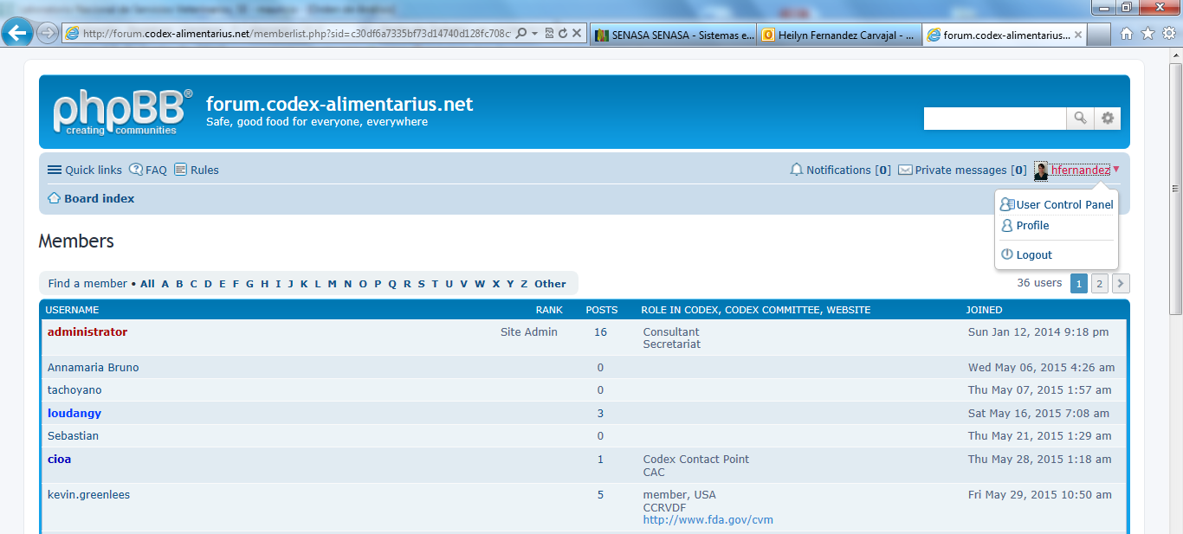

- Click “Usergroups”
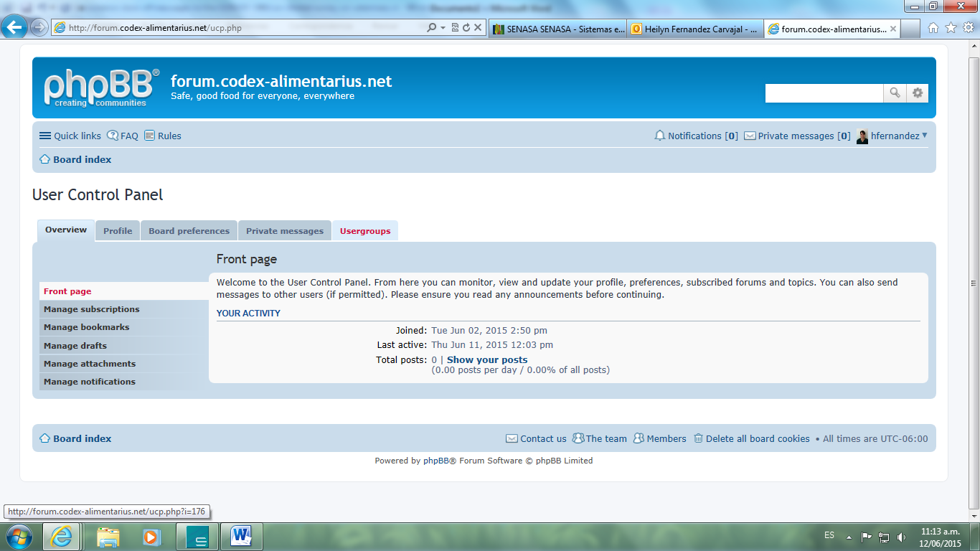

You will see the next screen. Select the user group you wish to join from those available in the bottom part of the page below the title “NON-Membership”.

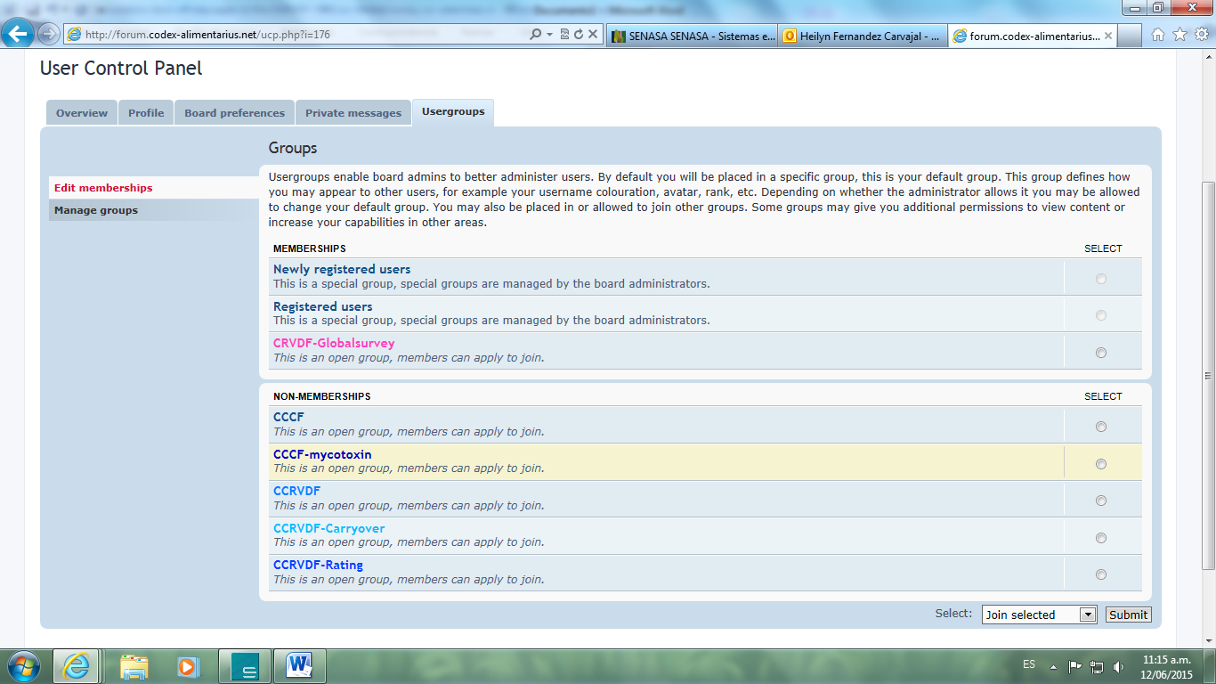
- Then, click the radio button “Select” to choose the forum you want to be part of and then click “Submit”.
Your request will be transmitted automatically to the moderators of the EWG who will admit you to the group thus allowing you to see the forum when you login.
After being admitted to the forum, it will appear at the top of the "Membership" the name of the EWG and you may receive information and post in the forum.
- How to receive an email when there is a new post in your forum
To receive an email when there is a new post in your forum make sure you “subscribe” to the forum by checking the subscribe button as indicated. NOTE: You are subscribed when the text changes to “Unsubscribe forum” as in the screen shot.
